California Casualty is dedicated to preserving the health and safety of ISTA Members and our employees. We are monitoring this ever-changing public health situation by the hour. This is an unprecedented time for everyone - a time that, for many, is filled with uncertainty. Our hearts and thoughts go out to each and every one of you.
Our primary focus is to minimize disruptions to our policyholders as we respond to concerns about the spread of Coronavirus (COVID-19). California Casualty remains committed to doing everything we can to serve your members, while keeping our employees safe.
ISTA Members can expect to continue to receive excellent service from California Casualty. The best ways to reach us include:
- Contacting us by phone at 1.800.800.9410. You can make a payment, file a claim, manage your account balance or ask a question.
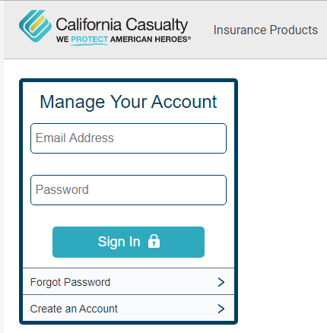
- Managing your policies online through the “Manage Your Policy “section of www.calcas.com website. You can pay your insurance bill, manage your policies, file a claim, or connect with us.
- New Accounts Representatives are available for purchasing a policy or requesting a quote, you may call 1.866.680.5143, please select option 2.
- Online “Click-to-Chat” option is also available for service.
California Casualty is following recommendations by the Centers for Disease Control (CDC), taking advantage of technology and making operational modifications as this situation evolves. We have cancelled all non-essential business travel, meetings and conferences for all employees, including our local field representatives. Our service centers are utilizing social distancing, undergoing deep cleaning, along with deploying telecommuting options for employees who may need to work from home to help ensure their health and safety and that of their family members. We are encouraging company communication with clients via virtual meetings through teleconference calls and video conferences.
Thank you for your patience as we all pull together in support of our communities, customers and employees. Please read a personal message from California Casualty’s CEO, Joe Volponi, below or at www.mycalcas.com

